Softuniada 2019

Moneypoly
Mr. Moneybags’s is a huge investor and a great businessman so it may come as no surprise that his favourite game is Moneypoly, it’s kind of like Monopoly, but a bit different. The game’s rules are very simple - the only player is Mr. Moneybags and he starts with an account balance of 0. The playing area consists of N indexed tiles, with Mr. Moneybags being able to move from one tile to another, only if they have a connection between them.
Each tile has an integer value associated with it - the investment result, representing the change to Mr. Moneybags’s account balance as result of his investment in the tile (a positive number meaning the investment paid off and Mr. Moneybags gained money and a negative number meaning the investment failed and Mr. Moneybags lost money).
Each connection between tiles has an integer value associated with it – the investment time, representing the amount of time it would take Mr. Moneybags to move to and acquire the tile on the other end of the connection.
Mr. Moneybags starts the game by stepping on the starting tile (tile with index 0), each time he steps on(invests in) a tile he will modify his account balance with the tile’s investment result and write the index of the tile in his investment history. After every investment, Mr. Moneybag can choose to either end the game or move to an adjacent tile that has a connection to the tile he is currently stepping on.
Mr. Moneybags believes in an optimized supply chain, so when the game begins he will choose the set of connections with the smallest combined investment time, that would also provide him a path to every reachable tile, and will then only move using connections in that set. One more thing, since Mr. Moneybags is good friends with the banks, while moving between tiles, he has the option to declare bankruptcy, setting his account balance to 0, and deleting his investment history, though he still lands on the tile he is moving to and has to modify his new account balance and investment history accordingly. Regardless of whether Mr. Moneybags has declared bankruptcy or not he will never visit the same tile more than once.
The goal is to find the highest account balance Mr. Moneybags can acquire and the indexes of the investments he had to take to get it.

Input
- On the first line you receive the number N – the number of tiles, with the tiles being indexed from [0…N).
- On the next N lines you receive in ascending order the index of each tile with its associated investment result in the format “{index} {investment result}”.
- On the next lines, until the command “end” is received you will receive information about a connection in the format “{tile1} {tile2} {investment time}”.

Output
- On the first line of the output, you need to print the highest account balance Mr. Moneybags can get.
- On the second line print the indexes of investments he had to take as a space separated sequence, with the numbers sorted in ascending order.

Constraints
- The Indexes of the tiles will always be the numbers [0…N-1].
- The number of tiles N will be between [2…20 000].
- The investment result of each tile will be an integer in the range [-1000…-1] ∪ [1…1000]
- The investment time of each connection will be an integer in the range [-1000…1000]
- In case there are 2 or more connections, each of which can form its own set of connections with the lowest combined investment time, Mr. Moneybags will always take the connection ending in the tile with the lower numerical index (i.e. if we have a choice between 0->1 and 3->2, he will chose 0->1 – because 1 < 2). In case the 2 connections end in the same tile, he will always take the connection with the lower starting index (i.e. if we have a choice between 3->7 and 5->7, he will always choose 3->7, because 3 < 5).
- There will never be more than one set of investments, that Mr. Moneybags can take which grants the highest account balance.
- Mr. Moneybags will never visit a tile more than once.
- Mr. Moneybags will always start on the tile with index 0.
- Each connection can be traversed both ways.
- There will never be a connection between a tile and itself.
- Allowed time: 600 ms Allowed memory: 32 MB.

Examples

Input | Visualization | Output
5  0 7  1 3  2 2  3 3  4 2  2 3 9  0 3 2  3 4 3  1 3 4  0 4 14  4 2 5  end | 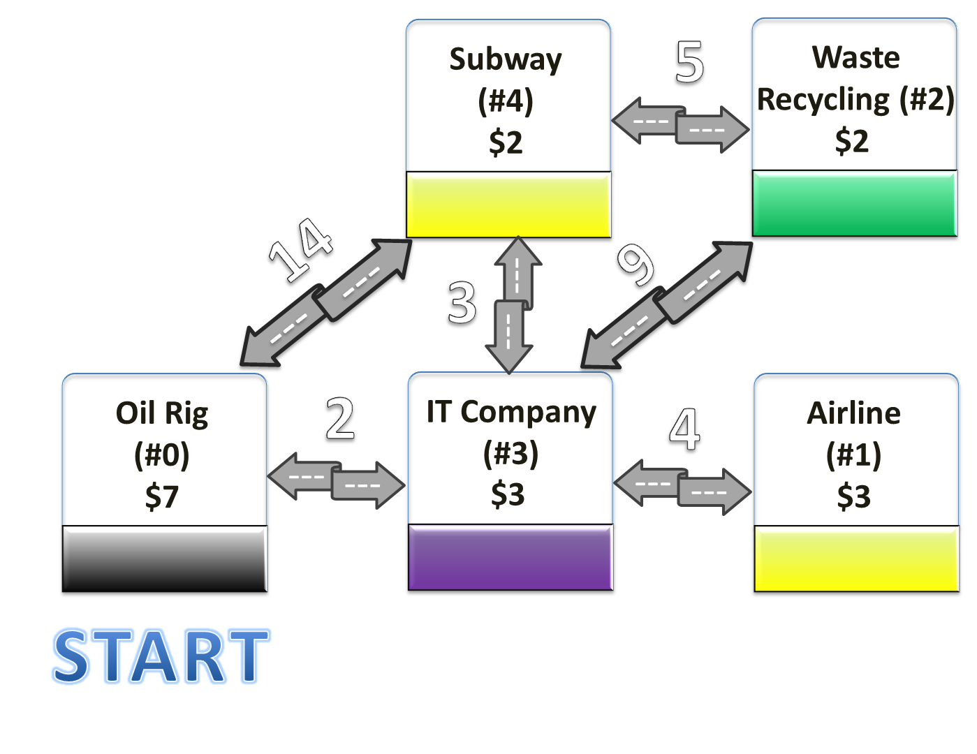 | 14  0 2 3 4
Comments
Mr. Moneybags start on the Oil Rig (#0) and add its investment result to his account balance:
Account Balance: 0 + 7 = 7
Investment History: #0
Now we have a choice between ending the game, going to #4 or going to #3, we see we can make more profit if we go to a tile, so we decide to continue the game. Since Mr. Moneybags will only move through the set of connections with the smallest combined investment time, we need to first find that set. Looking at the playing area we can see that the set of connections with the smallest combined investment time, that also allows Mr. Moneybags to reach every tile on the field, is the following:
#0 - #3, #1 - #3, #2 - #4, #3 - #4
Having found the set of connections, we see that our only possible move is to #3, so we decide to go to #3.
Account Balance: 7 + 3 = 10
Investment History: #0, #3
Now again we have a choice, we can end the game, go to #4, go to #2 or go to #1. Since again we can make more profit by going to a tile, we decide to continue the game. We see that #1 would give us the most money, however since Mr. Moneybags never steps on the same tile twice, if we go to it we would be stuck, so we decide NOT to go to #1. The only remaining choice that is part of the set is #4, so we decide to go to #4.
Account Balance: 10 + 2 = 12
Investment History: #0, #3, #4
Again we have a choice, we can end the game or go to #2, since again we can increase our account balance by going to #2 and the connection is in the set, we decide to continue the game and go to #2.
Account Balance: 12 + 2 = 14
Investment History: #0, #2, #3, #4
We have no more tiles we can visit, so we end the game, leading us to the answer of:
Account Balance: 14
Investment History: #0, #2, #3, #4

Input | Visualization | Output
4  0 -3  1 2  2 -1  3 -2  1 0 7  3 2 11  1 2 4  1 3 2  2 0 11  end | 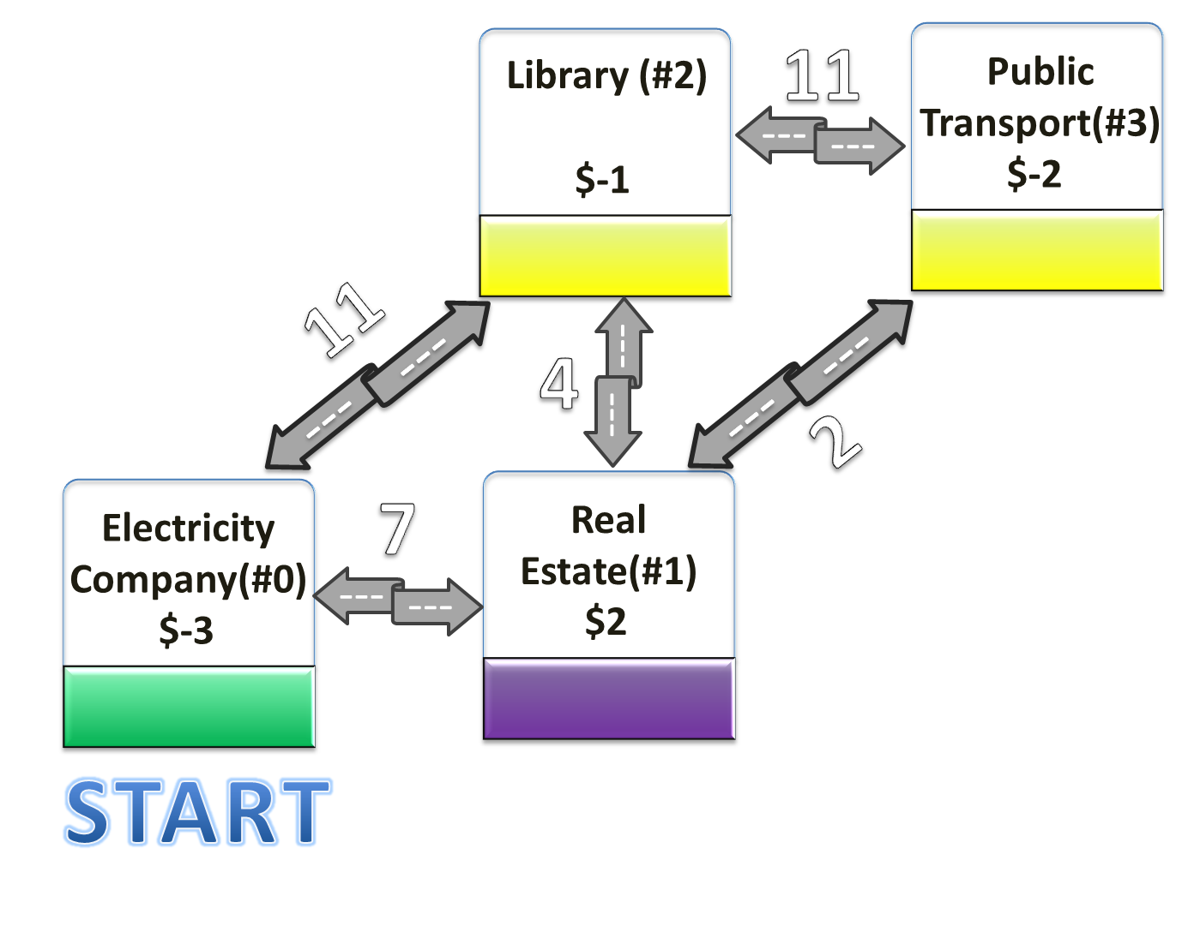 | 2  1
Comments
Mr. Moneybags starts on the Electricity Company (#0) , it turns out the investment was bad so we lose money:
Account Balance: 0 - 3 = -3
Investment History: #0
Now we have a choice between ending the game, going to #1 or going to #2, since going to #1 will make us money and the connection to it also is part of the set with the smallest combined investment time, we decide to continue playing and go to #1. Before stepping on #1, Mr. Moneybags uses his connections to the banks, to declare bankruptcy and have his account balance and investment history reset.
Account Balance: 0
Investment History:
After declaring bankruptcy, Mr. Moneybags lands on #1 and we modify his account balance and investment history accordingly:
Account Balance: 0 + 2 = 2
Investment History: #1
Now again we have a choice, we can end the game, go to #2 or go to #3. Since there doesn’t seem to be any more ways to increase our account balance, we decide it’s time to end the game. Mr. Moneybags’ final account balance and investment history are:
Account Balance: 2
Investment History: #1

